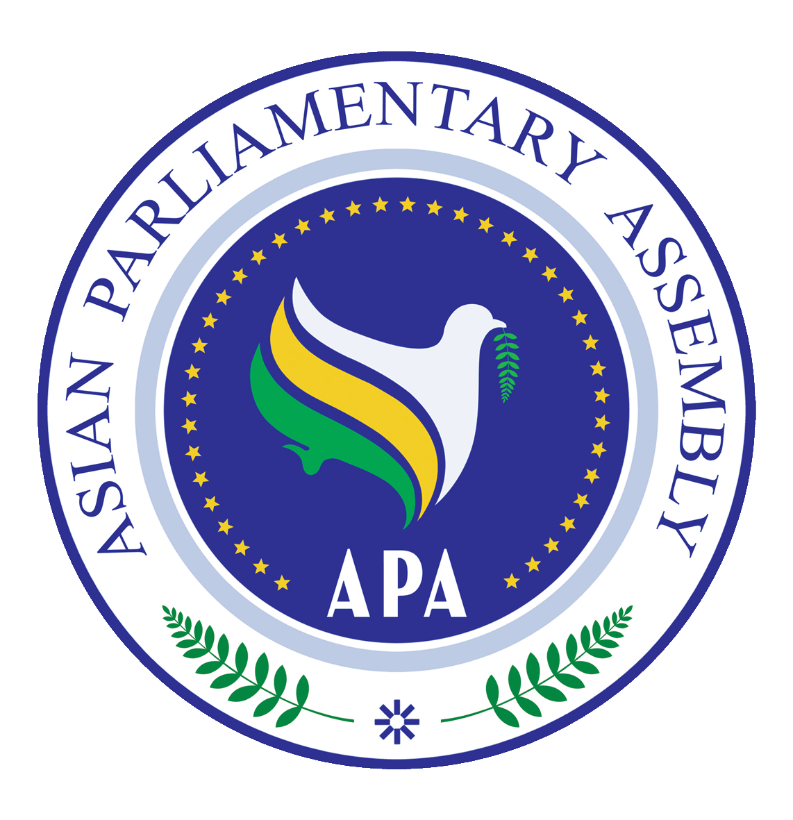 | Asian Parliamentary Assembly |  | SC-Budget and Planning/Draft Res/2025/01  23 December 2025  Qatar
Draft Resolution on Planning APA Budget
We, the Members of the Asian Parliamentary Assembly,
Recalling APA/Res/2008/04 and APA/ Res/2014/09 and other relevant APA documents;
Determined to enhance the efficiency and organizational capacity of the APA to achieve its goals and objectives enshrined in its Charter;
Underscoring the importance of participation by all Member Parliaments in equitably sharing the financial needs of the APA and its Secretariat on the agreed amount of annual contribution of 22,000 USD;
Emphasizing the principles of transparency, integrity, accountability, and efficient management of financial resources in APA budgeting and spending;

We therefore,
- Request all APA Member Parliaments to take required measures to secure the necessary funds for the payment of their annual contributions to the APA budget, according to their respective internal budget planning procedures and encourage them to make voluntary financial contributions to enhance the sustainability of the APA’S budget and decisions;
- Appreciate the provision of financial and logistical support to the APA Secretariat by the Islamic Parliament of Iran since 2007, and request the continuation of its generous support pending the full implementation of Financial Regulations and until the regular payments of assessed contributions by all Member Parliaments are made, tentatively for APA budget of 2026;
- Acknowledge the generosity of the APA President and Vice-Presidents in contributing to the APA expenses by hosting activities and meetings based on commitment to the APA Decision on Modalities for Effective Organization of the APA Meetings adopted by the 7th Plenary on 10 December 2013 through supporting APA Secretariat expenses;
- Request the Secretary General to prepare, while taking into consideration the annual assessed contributions of member Parliaments, the Draft APA Annual Budget based on the (Program & Performance Budget model), that requires programs, projects and expenses estimation based on the Assembly objectives, and on the policies and plans approved by consensus of the standing committee, and then to be presented to the APA Executive Council for final approval by consensus by the Plenary Session;
- Request the APA Secretary General to provide proposals to be considered in the next meeting of the Standing Committee, based on the views expressed by the APA President during the 13th Plenary on Revitalization for the enhancement of organizational capacity and its effectiveness;
- Allocate the APA Budget through the following three Items:
- Operational and Strategic Budget Item: expenses allocated initially upon the Budget approval and attestation.
- Additional Budget Item: amounts decided to be added to cover APA new projects and programs.
- Emergency Budget Item: which shall be determined by a decision of the APA Executive Council, to cover emergency events or incidents.
- The Secretary General is responsible for the implementation of the APA Budget and the management of its assets, determining the principles, objectives and rules for preparing the budget, to be submitted to the Standing Committee for budget and Planning;
- Recommend to exempt the Parliament of Palestine from the assessed contribution until the end of occupation, and the establishment of its independent state. Any other member parliaments wishing to exempted from payment of annual contribution must submit an official request to the Secretariat;
- Emphasizing the importance of establishing mechanisms to monitor the disbursement of funds to ensure that they are used for the purposes for which they were allocated, which enhances transparency and accountability;

